**Optimizing Product Pricing**

**Background**

The Book Emporium wants to price books to optimize profits. The spreadsheet for this homework has sales data on *Harry Potter* book 7. For each week, the Book Emporium varied prices on *Harry Potter* book 7 to determine a demand curve. The percent of customers who visited BookEmporium.com and purchased *Harry Potter* book 7 is shown in the spreadsheet. J.K. Rowling has announced a sequel to the *Harry Potter* series. Determine the price for the sequel.

**Resources**

Use the data set SCM 651 Homework 3 Book Prices spreadsheet.

**Definitions**

Price what you will charge each customer who purchases the new book

Book Cost what you must pay the publisher for each book

% purchased in your pricing test, the percent of people who bought at that price

Predicted % your regression model estimate of the percent sold based on price

Predicted sales estimate of number of customers who buy the book from you

Revenue total revenue generated (price * predicted sales)

Profit (price – book cost) * predicted sales

**Assumptions**

1. Assume that the demand for the book sequel will be similar to *Harry Potter* book 7.
2. Assume that 100,000 customers will consider purchasing a book from you.
3. The data is not an entirely accurate prediction of the demand, but a regression on the data using a power model will give a reasonable prediction.
4. Assume that you pay the publisher $5.00 for each book.

**Assignment**

**What’s due:**

Submit an analysis **before the live class in week 8**. Suggested length is 5 pages but should not exceed 10 pages, single-spaced, 12-point font. Use Excel to analyze the data and document your results in a Word document.

This is a group assignment; each student should upload a copy of the assignment to the learning management system. The paper must be a Microsoft Word document.You should also submit the Excel spreadsheet with the regression and optimization analysis. **Submit both your Word and Excel files.** Name the files HW3_Team# where # is your team number. Be sure to include the names of everyone on the team on the first page of the paper. Late assignments will not be accepted. Failure to follow directions will be penalized.

**Outline and grading criteria:**

1. Regression analysis (35%)
   1. Graph the percent purchased against price. (5%)

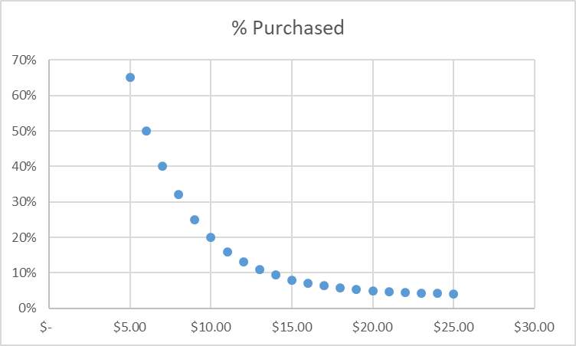

* 1. Perform a regression using **power** regression to determine the predicted % column.
     1. Estimate the equation of the line. (5%)

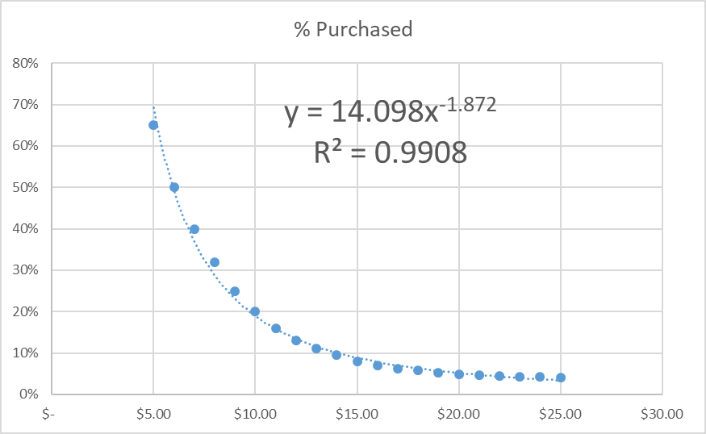

* + 1. What does the R2 mean? (5%)
       1. The R squared measures the percent change in Y, explained by X. In this case, the R squared of .9908 means that 99.08% of the change in predicted % purchased is determined by the price.
  1. Assuming there are 100,000 customers who visit your website, and the publisher cost is $5.00, estimate the number of books sold (predicted sales column). (5%)

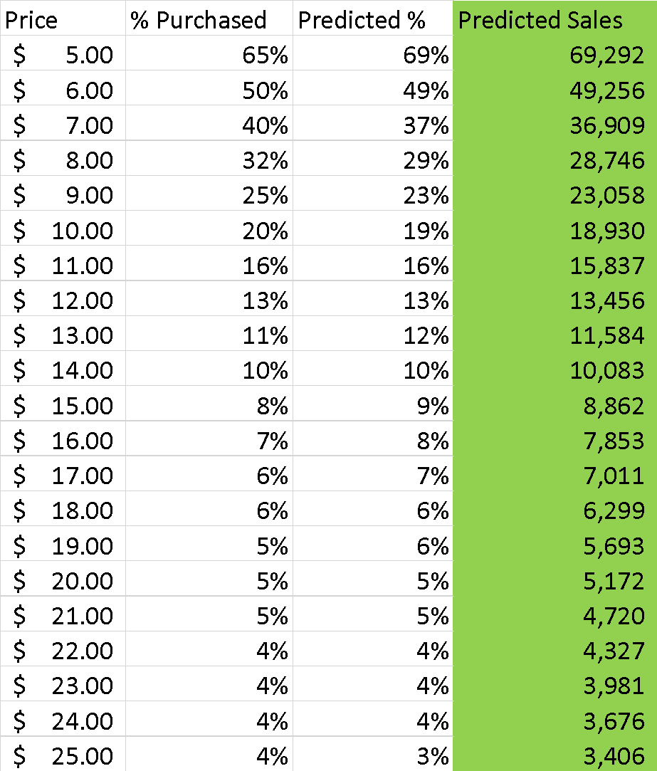

* 1. Calculate the revenue column (price * predicted sales). (5%)

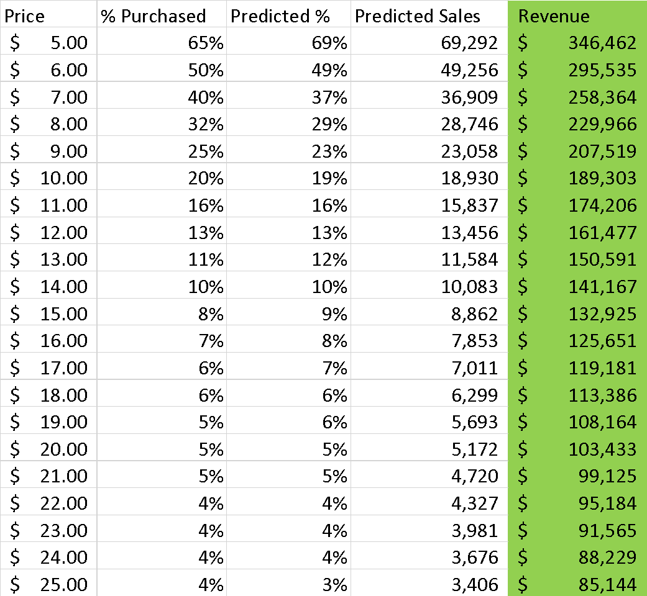

* 1. Calculate the profit column ((price – book cost) * predicted sales). (5%)

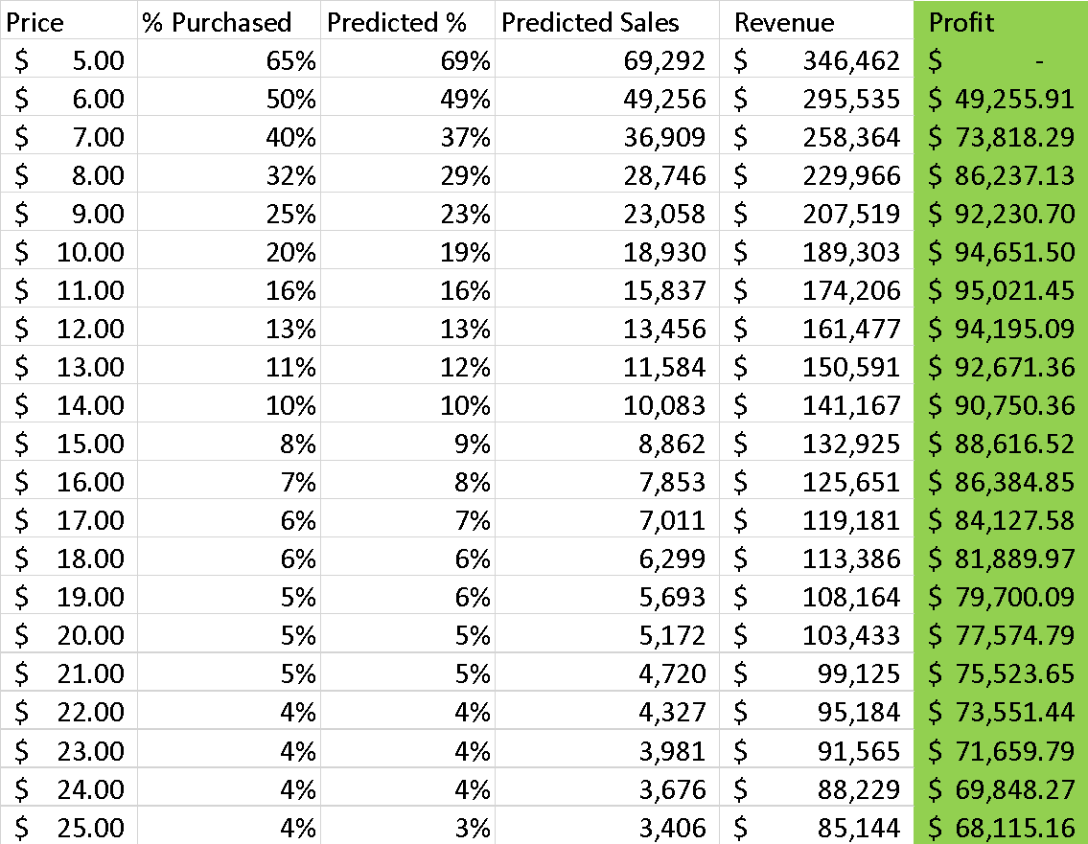

* 1. Use conditional formatting to highlight the profit values for all prices. (5%)

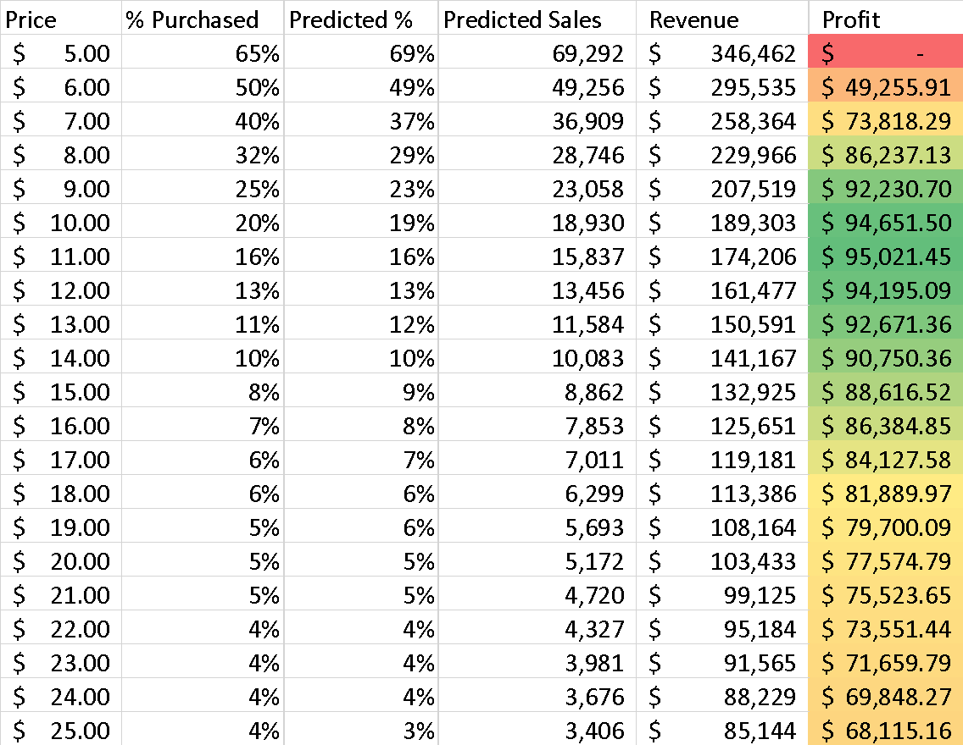

1. Optimization analysis (with constraints) (35%)
   1. Calculate the price point for the highest profit possible.
      1. The publisher will sell the books to you at $5.00 each with no minimum order. (10%)



* + 1. The publisher has agreed to sell you the books at $4.50 each if you sell at least 30,000. (10%)



* + 1. The publisher has agreed to sell you the books at $4.00 each if you sell at least 50,000. (10%)



* 1. Which solution results in the highest profit? What price do you charge customers? What cost do you pay the publisher? (5%)

Selling the book at $7.82 generates the highest profit at $99,586.53. The cost that the publisher will be paid is $4.50.

1. Discussion (30%)
   1. What are the risks of using *Harry Potter* book 7 data in predicting your new demand curve for the *Harry Potter* sequel? (15%)

One of the risks of using Harry Potter book 7 data to predict the new demand curve is that there may not be similar demand for the sequel based on opinions and feedback from fans regarding book 7. There is no guarantee that consumer preferences and purchasing behavior will be the same for both books. In addition, there is also no guarantee that with each sequel, sales will not naturally see a drop off in interest and lose overall attractiveness. Finally, if any of the components of marketing change, such as how the new book is promoted and in which mediums, there is no guarantee that past sales will dictate future sales. There are many variables that have to be taken into consideration, and as a result, there is no way to be 100% sure of the predictions.

* 1. What other data would you like to have to perform your analysis? (15%)

In order to assist with the analysis, our group would benefit from having additional data to assist our predictions. First, we would like to have data on whether or not the two books will be sold in the same format (digital, print or both). Second, our group would like to know if both books will be marketed in the same fashion, and in what mediums. Understanding the marketing strategy will provide insight into the potential effectiveness in creating anticipation from the fans. Third, we’d like to know about certain story aspects, such as if the book’s characters are the same and if the overall “universe” will change. Any main character changes could have a huge impact on sales, as many fans become attached to the world and may not be as excited for something completely different, thus lowering the demand. This type of behavior was present during the Star Wars sequel trilogy where devoted fans were divided on the story line that the new movies were taking the entire franchise. Fourth, it will be beneficial to know the sale numbers from Harry Potter Book 6, and see how they compare to book 7. Eliminating the assumption that fans of JK Rowling might not be as interested in new characters, we can use that comparison as a gauge to compare the sequel to book 7. Demand for JK Rowling’s other series outside of Harry Potter’s can help us understand the prediction for the sequel as well. Fifth, we are basing our predictions off of current publishing costs and those prices are likely to naturally increase over time. We would need to have an understanding of what publishing costs will be at the time book production begins. Lastly, our group will benefit from understanding the desired release date for the book, how other books typically perform when released to the public at the same time, and data on increased reading periods. For example, based on the target audience JK Rowling is focused on, summer months are usually time frames where teenagers and young adults are able to read more due to less demand from school work. Understanding the seasonality of book sales, seasonality of increased reading periods and seeing if the release date of the new book is being sold during a time of high sales would allow our group to make more informed predictions.